**X-CALI**

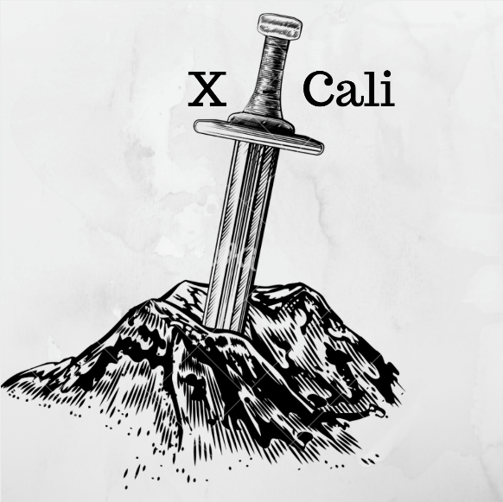

**Critical Design Review Report**

*“Design of Robots Collaboratively Carrying a Long Object Through an Open-Top Maze”*

Submitted to: Ali Özgür Yılmaz

Date of Submission: March 9, 2018

**Company Shareholders**

* Oytun Akpulat 2093201 [oytun.akpulat@metu.edu.tr](mailto:oytun.akpulat@metu.edu.tr)
* Göksenin Hande Bayazıt 2093441 [hande.bayazit@metu.edu.tr](mailto:hande.bayazit@metu.edu.tr)
* Emre Doğan 2093656 [dogan.emre@metu.edu.tr](mailto:dogan.emre@metu.edu.tr)
* Taha Doğan 2093672 [taha.dogan@metu.edu.tr](mailto:taha.dogan@metu.edu.tr)
* Burak Sezgin 2094456 [burak.sezgin@metu.edu.tr](mailto:burak.sezgin@metu.edu.tr)

İçindekiler

Introduction 3

Design Description 3

System Description 3

Subsystem Analysis 3

Body: plank, şase boyutları, pil 3

Detection: kameralar, sensörler, algoritma 3

Movement: tekerler motorlar, algoritma 3

Component Analysis 3

Microcontrollers: RP3, Arduino Uno 3

Sensors: Ultrasonic, IR 3

Motors: 3

Chassis: wooden 3

Wheels: material, plastic mad wheel: aluminum 3

Requirement Analysis 3

Risk Analysis 3

Power Consumption Analysis 3

Cost Analysis 3

Development Schedule 3

Modification to Conceptual Design 3

Test Procedures and Test Results 3

Organization Plan 3

Conclusion 3

References 3

# Introduction

# Design Description

## System Description

## Subsystem Analysis

### Body: plank, şase boyutları, pil

### Detection: kameralar, sensörler, algoritma

### Movement: tekerler motorlar, algoritma

## Component Analysis

### Microcontrollers: RP3, Arduino Uno

### Sensors: Ultrasonic, IR

### Motors:

### Chassis: wooden

### Wheels: material, plastic mad wheel: aluminum

## Requirement Analysis

## Risk Analysis

## Power Consumption Analysis

## Cost Analysis

## Development Schedule

# Modification to Conceptual Design

# Test Procedures and Test Results

# Organization Plan

Figure XXXXXXXXX: Organizational Structure of X-Cali

# Conclusion

# References